Project Overview
Project: Personal Portfolio Website
Internship domain: Front-End Development
Core technologies: HTML5, CSS3, and JavaScript
This report documents the project completed for the corresponding CodeAlpha Front-End Development task. Descriptions of optional or implementation-dependent features should be checked against the final source code before submission.
1. Introduction
The Personal Portfolio Website was completed as part of my CodeAlpha Front-End Development Internship. The project presents a developer's profile, skills, projects, and contact information in a single website.
2. Project Objectives
- Design a personal portfolio using HTML and CSS, with JavaScript where needed.
- Showcase personal and educational information.
- Present technical skills and completed projects.
- Include resume and contact information.
- Create a clean, responsive layout with sections such as About and Projects.
- Add smooth scrolling, animations, and hover effects where implemented.
3. Technologies Used
- HTML5 — structures the portfolio sections and content.
- CSS3 — controls the page layout, typography, colors, spacing, responsive behavior, and visual effects.
- JavaScript — supports interactive elements and navigation where required by the implementation.
4. Project Design and Structure
The portfolio is organized into clearly identified sections. Depending on the final implementation, these may include Home, About, Skills, Projects, Resume, and Contact. This structure helps visitors find information about the developer and their work.
5. Implementation
- HTML structure: create the page sections and organize profile information, skills, project descriptions, resume details, and contact information.
- CSS styling: apply a consistent visual design, readable typography, spacing, section layouts, and responsive rules.
- JavaScript behavior: add interactive navigation or other page behavior where used. Smooth scrolling, animations, and hover effects can be implemented with CSS and/or JavaScript as appropriate.
6. Main Features
- Personal introduction or Home section.
- About section.
- Technical Skills section.
- Projects showcase.
- Resume information or link.
- Contact information.
- Responsive layout.
- Optional enhancements: smooth scrolling, animations, hover effects, and deployment on GitHub Pages or Netlify, if completed.
7. Conclusion
The Personal Portfolio Website task helped me apply front-end development skills to create a professional online presentation of skills and projects. It also demonstrated how a structured, responsive website can communicate a developer's work clearly.
8. Project Screenshots
Insert screenshots from your own completed project in the spaces below. Use genuine screenshots of the submitted application; do not leave the placeholders in the final submission.
Figure 1. Home or introduction section
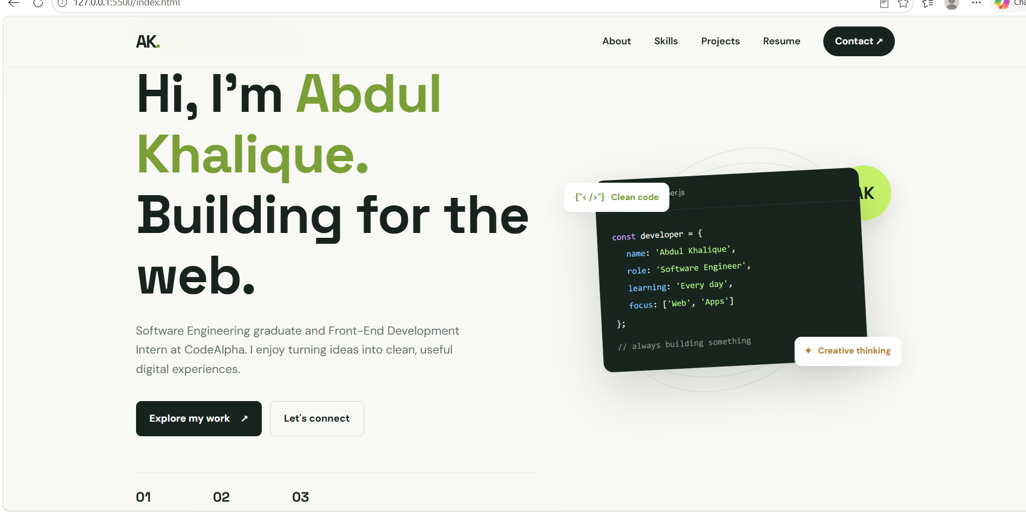
Figure 2. Skills and projects sections



